Solar power a money-spinner for women spinning eri silk yarn
Spinning eri silk yarn – though tedious and time-consuming with a traditional tool – is a way of life for women in Meghalaya. Using solar-powered spinning machines, they now spin more yarn and earn more.
- Rinlan Phungther May 16, 2024 Ri Bhoi, Meghalaya
Like most women in Meghalaya, Jacinta Maslai of Warmasaw village in Ri Bhoi district could spin eri silk yarn. But she could not earn much from it since it is time-consuming.
Maslai and her husband are farmers. She would also go to the local market to sell their agricultural produce. Their farm income was barely enough to run the family.
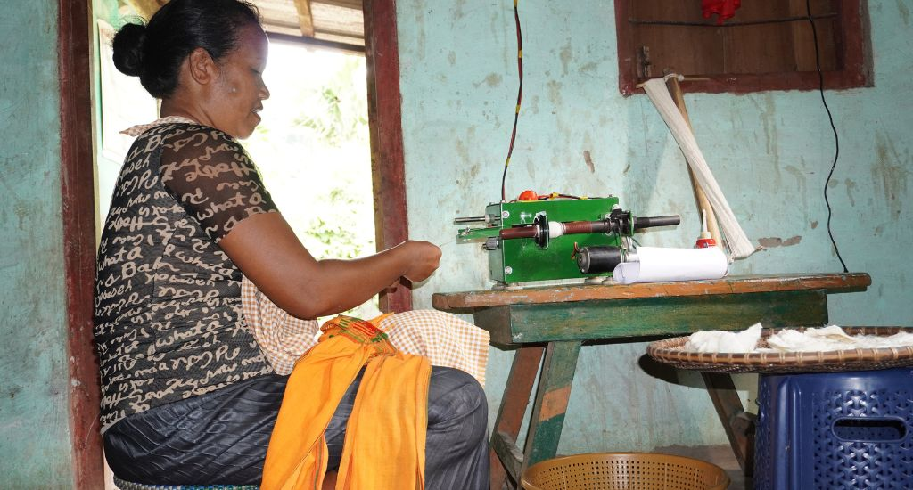Women like Jacinta Maslai have been able to increase their income by using a solar-powered eri silk yarn spinner
But with a solar-powered spinning machine to make eri silk yarn, now she can make more yarn and earn more. With her income from spinning yarn, she pays for her children’s education and also bears the household expenses.
The traditional method of making eri silk yarn
Eri is a beautiful silk fabric that the tribes of Meghalaya take pride in making. People in hundreds of villages across the state produce and wear eri silk clothes. Eri silk is eco-friendly since the silk yarn is extracted from cocoons without killing the worms.
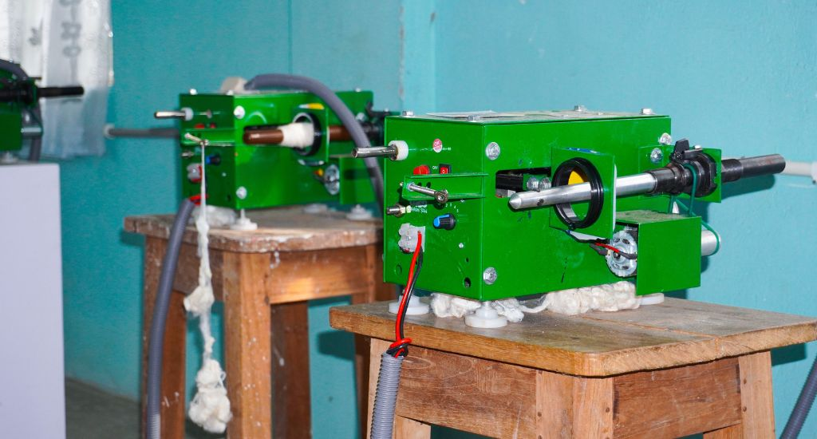
Mechanised spinning using solar power helps women spin eri silk yarn faster
Ri-Bhoi district is famous for its eri silk clusters where women are engaged in rearing cocoons, spinning yarn, natural dyeing, and weaving. Apart from agriculture and horticulture, sericulture and weaving are the prominent livelihood activities.
Traditionally women use a hand-held tool named takli – which is passed down through generations – to make the silk yarn.
It is a labour and time-intensive activity. The process requires keeping the hand in a raised position for extended periods for better quality. It takes one month to spin a kg of yarn.
Decentralised renewable energy
Since most of the areas have erratic or no power supply due to their remoteness and tough terrain, decentralised renewable energy is a viable solution to meet the villagers’ electricity needs and to improve their livelihood activities.
Watch: Reviving muga silk and more at Majuli island
MOSONiE Socio Economic Foundation (the tribal word mosonie means common wealth), a Ri Bhoi-based non-profit organisation, in collaboration with Selco Foundation introduced decentralised renewable energy (DRE) solution for livelihoods in 2017.
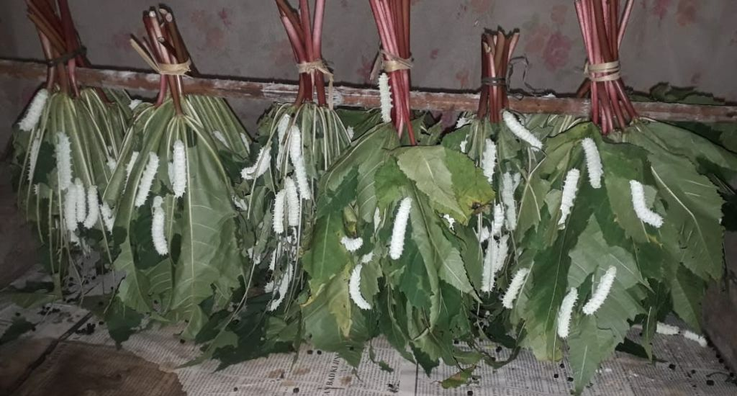 ErEri silk is eco-friendly as the silk is extracted without killing the worms
This fills the energy gap and reduces the drudgery involved in livelihood activities. So far, through this joint intervention, 250 households have received solar solutions, out of which 117 are eri-spinning micro-enterprises.
The solar-powered eri silk yarn spinners are of different wattage that could enable spinning for 5–8 hours. In addition to the solar panel, the unit has a battery and an LED bulb.
Solar-powered spinning machines benefit women
The DRE intervention for livelihood focusses largely on women as traditionally they tend to be the spinners in this area. The households for the intervention are generally identified after awareness programmes and field visits via a baseline survey.

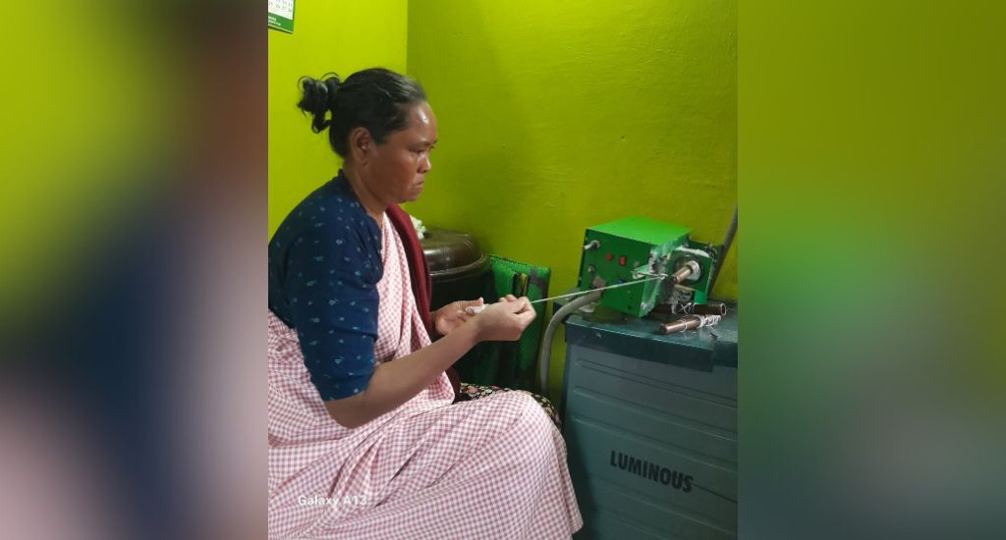
Ritngen Lamare of Liarkhla village used a traditional takli to spin the yarn before solar panels were installed
The women are linked to financial Institutions such as banks and village organisations for loans. As the women are not familiar with the solar-powered spinning machines, capacity-building training helps them handle the machines.
A typical eri silk spinning machine costs Rs 25,000–35,000. MOSONiE and Selco link them up with financial institutions and banks for financing the solar-powered spinning machines and also provide gap support to economically weak end users.
Through the DRE intervention, the spinning time has been reduced. The women are now able to produce up to 4 kg of yarn against the 1 kg they produced earlier. Ritngen Lamare of Liarkhla village in Bhoirymbong administrative block could only spin one kg of yarn in two months using a takli. Now she spins 2–4 kg of eri silk yarn per month.
Empowered women
The average income of the women has increased from Rs 1,200 to Rs 7,000 per month. Due to the increased income, this has become the primary occupation for a few households now. A reliable and dependent source of energy allows the women spinners of Ri Bhoi and their households independence.
Also Read: Kamrup women lead Eri silk revival for improved livelihoods
When Lamare’s son was injured in an accident, he had to refrain from the use of his leg and hence from engaging in any outdoor work. But he learnt to spin the eri silk yarn from his mother and has made it his livelihood now.

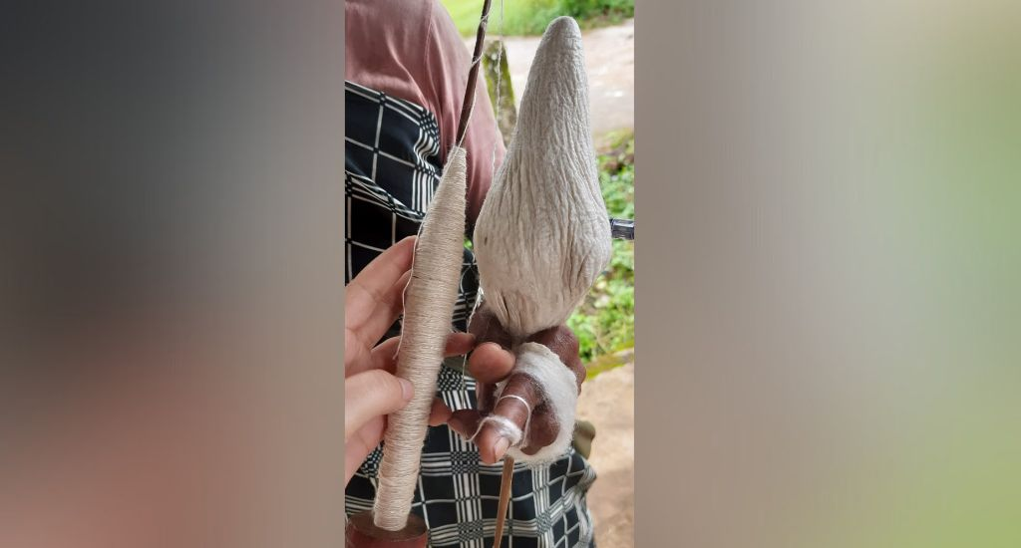
A traditional takli used to spin the eri silk yarn
The DRE intervention has created a platform for rural women to become micro-entrepreneurs. They have attained a better standard of living and quality of life by sustaining their income through producing and selling their products.
Seeing the impact and need in the region, MOSONiE and Selco have set up three training centres in different rural areas of Ri Bhoi district. It will create an opportunity for women to access training easily and spin freely by bringing their own materials. It will also help small entrepreneurs to work efficiently and create a model where solutions can be adopted or replicated in other areas.
The lead image shows a solar panel used to power the eri silk yarn spinning machines
Rinlan Phungther holds a master’s degree in social work. She is the HR manager at MOSONiE Socio Economic Foundation.

